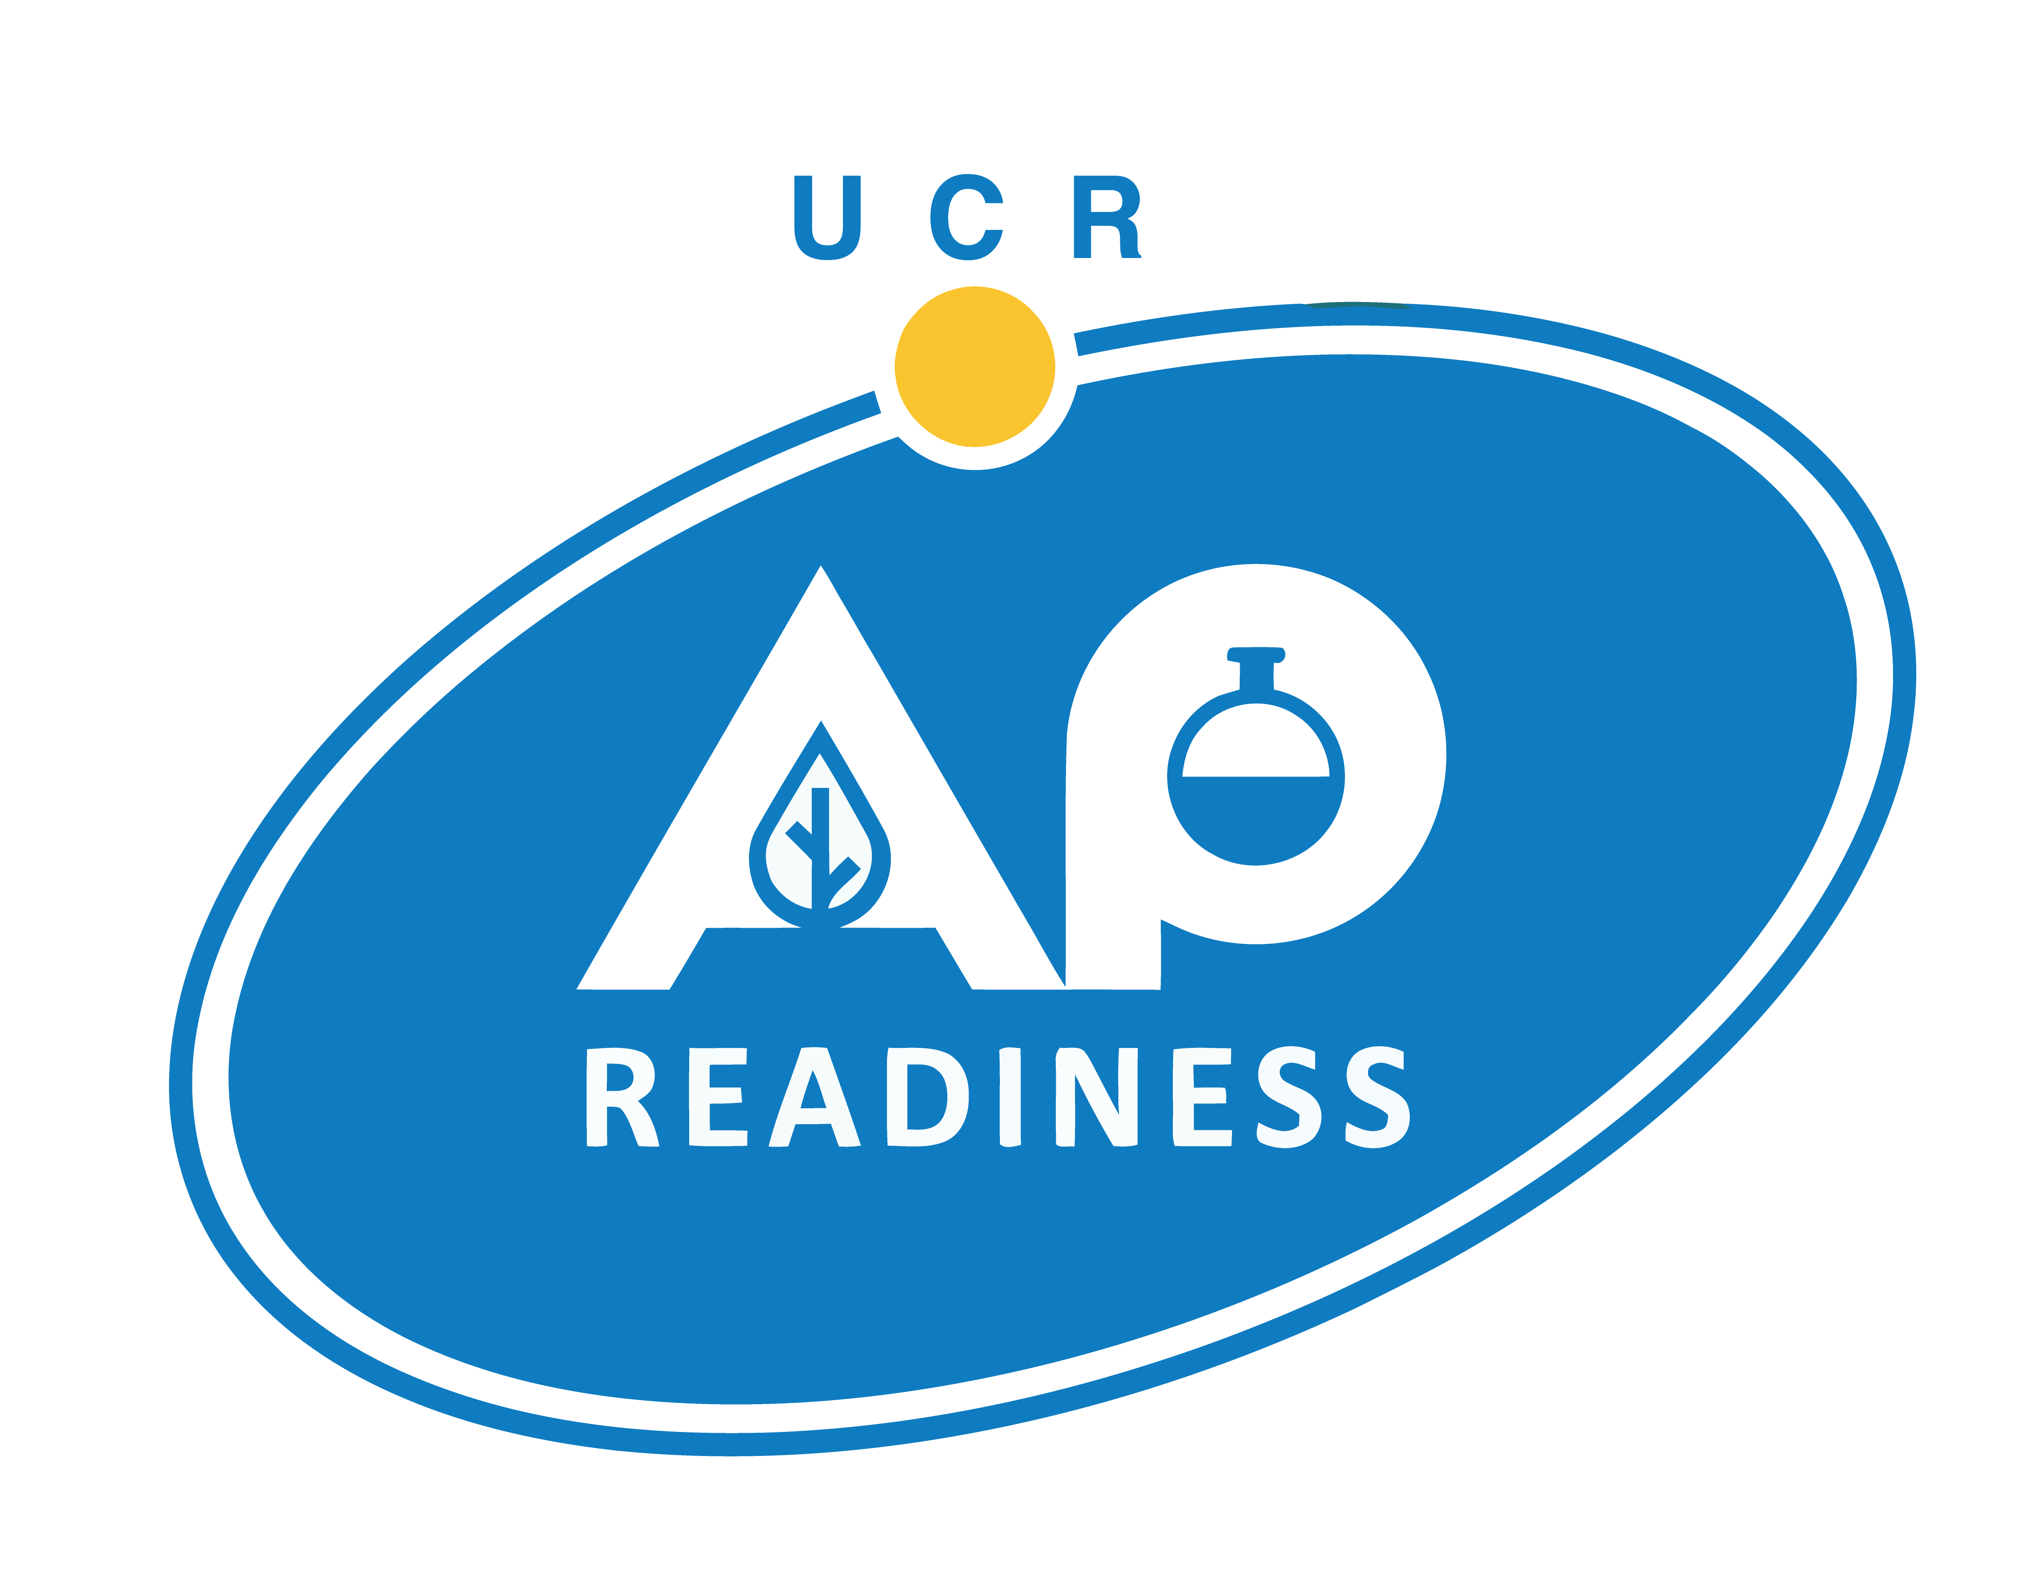

AP Readiness AGENDA – November 7, 2026

Educators & APR Instructors Check-in > Sproul 1102

STUDENT SIGN-IN > https://bit.ly/aprstudent26-27

Handouts/Materials - https://bit.ly/aprmaterials

AM Session 9:00-10:45 AM Break 10:45-11:15 AM PM Session 11:15AM-1:00 PM

BIOLOGY Room (New Building)
Cell Membrane Structure, Osmosis & Water Potential Practice Problems | Humanities Bldg. 1402
Cell Membrane Transport | Humanities Bldg. 1403
Cellular Respiration & ATP | Humanities Bldg. 1400
Enzymes and ATP | Humanities Bldg. 1401

CALCULUS AB Room (New Building)
AM Session: Relative and Absolute Extrema  PM Session: Second Derivative Applications | Humanities Bldg. 1501
Introduction to Antiderivatives & the Fundamental Theorem of Calculus | Humanities Bldg. 1503

CHEMISTRY Room (New Building)
AM Session: Chemical Reactions (An Overview)  PM Session: Redox Reactions | Sproul Hall 1340

ENGLISH LANGUAGE Room
From Prompt to Position: Getting Started with FRQ3 | Sproul Hall 2343
Rhetorical Analysis | Sproul Hall 2339
Sharpening the Argument Essay | Sproul Hall 2355
Synthesis Essay: Recipe for Success | Sproul Hall 2351

ENGLISH LITERATURE Room
Don't You Forget About the MCQ | Sproul Hall 2361
Poetry: Devices and Places of Complexity | Sproul Hall 2360
Question 2 - Prose Analysis | Sproul Hall 2365

HUMAN GEOGRAPHY Room
5.3 Green Revolution | Watkins 1111
Political Boundaries - Types and Functions | Watkins 1101
Political Geography - Devolutionary Pressures | Watkins 1000

PHYSICS Room
Centripetal Motion & Universal Gravitation | Sproul Hall 2340

UNITED STATES HISTORY Room (New Building)
Jeffersonian to Jacksonian Democracy | Sproul Hall 1358
Review Time Periods 1-4 + SAQ Practice | Sproul Hall 2356

WORLD HISTORY Room
Political & Social Developments Leading the Trans-Atlantic Slave Trade | Humanities Bldg. 1405
The Columbian Exchange and the SAQ | Humanities Bldg. 1404
War and Roads - The Story of Eurasia and the Mongols: SAQ | Humanities Bldg. 1406

Student Evaluation - https://bit.ly/apreval26-27

