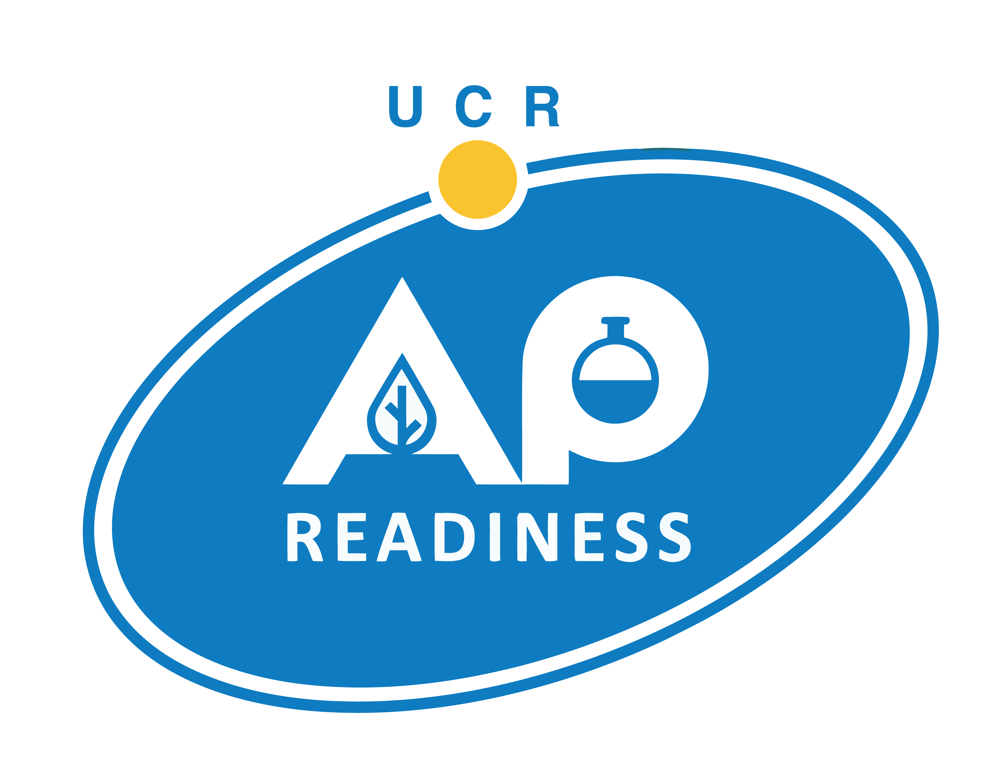


AP Readiness AGENDA – January 14, 2023

- AM Session > 8:50 AM -10:45 AM
- Break > 10:45 AM – 11:00 AM
- PM Session > 11:00 AM -1:00 PM

STUDENT SIGN-IN for ALL Classes > https://bit.ly/aprattend22-23

EDUCATOR SIGN-IN for ALL Classes > https://bit.ly/apreducator2022

Handouts/Materials - https://bit.ly/aprmaterials22-23

You are required to attend a class in the AM Session & the PM Session. Please Sign-In at Both.

BIOLOGY Instructor Zoom Link
DNA History and Replication | Lord | https://us06web.zoom.us/j/85241970566
 | Ramsey | https://us06web.zoom.us/j/83810253661

CALCULUS Instructor Zoom Link
Comprehensive Review for Integration | Ramaswamy | https://us06web.zoom.us/j/81343490848
AP Style Multiple-Choice Questions:  Differential Calculus Review | Ramirez | https://us06web.zoom.us/j/82184506144

CHEMISTRY (All Day Class) Instructor Zoom Link
Chemical Kinetics | Andrews | https://us06web.zoom.us/j/89007422410

COMPUTER SCIENCE PRINCIPLES (All Day Class) Instructor Zoom Link
Big Data, Data Analysis & Visualization,  Robot Code MC, Create PT | Kim | https://us06web.zoom.us/j/83286684732

ENGLISH LANGUAGE Instructor Zoom Link
Macro Learning® Resources for AP English Language & The AP Exam | Avne | https://us06web.zoom.us/j/85900812396
Multiple Choice Strategies | Turnbull | https://us06web.zoom.us/j/82634048528

ENGLISH LITERATURE (All Day Class) Instructor Zoom Link
Prosody and Stanzaic Forms | Gordon | https://us06web.zoom.us/j/82675751481

HUMAN GEOGRAPHY Instructor Zoom Link
5.10 – Consequences of Agricultural Practices | Daarstad | https://us06web.zoom.us/j/85468010752
Agricultural Revolutions and Practices | Cisneros | https://us06web.zoom.us/j/88251337835
Political Geography: History and Boundaries | Lee | https://us06web.zoom.us/j/84569402477

STUDENTS –
Remember to Complete Sign-In Form for Both AM & PM Sessions - https://bit.ly/aprattend22-23

Please complete the Evaluation
Students - https://bit.ly/apreval22-23
Educators - https://bit.ly/apreducatoreval2022

Next UCR AP Readiness is February 4, 2023!

AP Readiness AGENDA – January 14, 2023

- AM Session > 8:50 AM -10:45 AM
- Break > 10:45 AM – 11:00 AM
- PM Session > 11:00 AM -1:00 PM

STUDENT SIGN-IN for ALL Classes > https://bit.ly/aprattend22-23

EDUCATOR SIGN-IN for ALL Classes > https://bit.ly/apreducator2022

Handouts/Materials - https://bit.ly/aprmaterials22-23

You are required to attend a class in the AM Session & the PM Session. Please Sign-In at Both.

PHYSICS (All Day Class) Instructor Zoom Link
Momentum & Impulse | DiPasquale-Yu | https://us06web.zoom.us/j/89405478959

SPANISH LANGUAGE Instructor Zoom Link
Comparación Cultural. Analizar la cultura | De Nieves | https://us06web.zoom.us/j/87331663599
Comunicación interpersonal: Conversación | Estangui | https://us06web.zoom.us/j/88467458657

STATISTICS (All Day Class) Instructor Zoom Link
Confidence Intervals | Ferreria | https://us06web.zoom.us/j/82134194839

UNITED STATES HISTORY Instructor Zoom Link
Industrialization DBQ Document Sourcing  and Essay Writing | Abovian | https://us06web.zoom.us/j/85374876468
African/American Experience 1865-1920 (w. comparison of Booker T. Washington and W.E.B. DuBois) | Hromadka | https://us06web.zoom.us/j/86234434935

WORLD HISTORY Instructor Zoom Link
Review of Unit 3 and 4 (1450-1750) utilizing Stimulus Based Multiple Choice Questions (MCQ) | Herbst | https://us06web.zoom.us/j/85634919868
The Enlightenment | Gonzalez | https://us06web.zoom.us/j/85720474614

Support Room Hosts Zoom Link
AP Readiness Headquarters | Sandoval & Keipp | https://bit.ly/aprheadquarters

STUDENTS –
Remember to Complete Sign-In Form for Both AM & PM Sessions - https://bit.ly/aprattend22-23

Please complete the Evaluation
Students - https://bit.ly/apreval22-23
Educators - https://bit.ly/apreducatoreval2022

Next UCR AP Readiness is February 4, 2023!

